As warriors we’ve been trained that the most dangerous place on the battlefield is wherever we are alone. Warrior Reunion Foundation believes the same applies when we return home. It is our honor to work with fellow combat veterans who are eager to reconnect with brothers and sisters in arms.
On behalf of all members of our team, Warrior Reunion Foundation welcomes you to the life-changing process of reconnection at the small-unit level.
Your reunion mission begins today.

WHO WE ARE: Warrior Reunion Foundation is not your typical Veteran Support Organization. Founded by two Marine combat veterans, we strive to incorporate our warfighting principles in service of our new mission: to ensure every combat veteran has the opportunity to reunite, remember and renew bonds forged in the cauldron of combat.
We operate lean and hyper-focused. We have a small team of combat veterans who understand the power of reunions because we have each hosted our own.
We exist with only one purpose: to help fellow warriors realize their reunion vision. No fluff, no frills, no handouts – just reunions.

WHAT WE OFFER: Our unit reunion program is a partnership. We partner with every unit we serve to ensure the success of their reunion mission. This is accomplished through:
- A three-to-six month guided planning process: Our process is proven and battle-tested through nine reunions and counting. Our team walks each unit through a detailed planning process, ensuring all needs are met.
- Financial support: WRF covers all costs associated with reunion planning and execution. Travel support is available based on individual need.
- Flawless execution: WRF staff is on-site to manage reunion execution, enabling all unit members to focus on and fully enjoy the experience.
HOW IT WORKS: Below is a sample timeline of our reunion planning process. Our mission is to help each unit realize their own unique vision. No two reunions are the same. This reunion is yours!
R+180: Application for reunion support received
R+170: Initial phone conference with unit members – discuss WRF unit reunion process, requirements, unit “vision” and “the Big 3”
R+160: Unit Planning Coordinators (UPCs) designated; private unit Facebook reunion event page published for outreach/communication/coordination; initial polling of members for location & timing preferences
R+120: KICK-OFF Call – “Big 3” established (expected attendance, regional location of reunion, and date); WRF team begins venue search process; planning timeline and bi-weekly call schedule set
R+90: Reunion venue secured with hard dates in accordance with unit preferences; registration website launched: registration announced and opened to all unit members and Gold Star family members (when applicable)
R+75: Logistical planning items finalized e.g. T-shirt design, commemorative gift, chow plan etc. Reunion activity preferences submitted by UPCs; Memorial Service support outreach confirmed; Gold Star family accommodations confirmed (when applicable)
R+60: Sequence of Events (SOE) draft formalized: all reunion weekend activities confirmed; weekend transportation booked
Transportation support outreach for all unit members requiring assistance
R+45: SOE published to all unit members; all event and logistical support requirements confirmed; all travel support booked for unit members
R+30: Final planning begins: weekly planning calls begin; final coordination of all reunion activities; packing list and coordinating instructions confirmed and disseminated to all unit members
R+15: Final reunion confirmation brief with UPCs
R+1: WRF staff and unit advance party conducts on-site setup
Our guided planning process ensures no facet of a successful reunion is left to chance. When complete, each unit will have a detailed SOE that realizes their vision for an unforgettable reunion experience.

EXPECTATIONS: During the course of our lifetime we will likely only have a handful of opportunities to be surrounded by those we fought alongside (if we are lucky). We are committed to ensuring these rare opportunities are not wasted. As such, we expect the following from our unit partners:
- Commitment: We will be as committed to the success of your reunion as you are: no more and no less. This program is not a handout and it is not a blank check. We will provide for all your needs, and we expect each member of the unit planning committee to fully participate in the planning work with our team to make the reunion successful.
- Respect: Each reunion touches the local community in which it is held. We partner with venues to provide accommodations and experiences for each reunion, and activities often involve off-site travel and interaction with non-unit members. We expect every attendee to act in a fashion that maintains the honor of the unit and the reputation of our organization.

ENDSTATE: Our goals for every unit we support are:
- An unforgettable reunion experience with memories to last a lifetime
- Strengthened connections amongst unit members, to include plans for future gatherings and reunions
- Connections to actionable resources to support individual transition needs

OUTCOMES: We believe the most important ingredient to our success is continued connection to our fellow warriors. The following page includes several photos and testimonials which offer a snapshot of the reunion experience and the unparalleled impact of reconnecting with your unit.

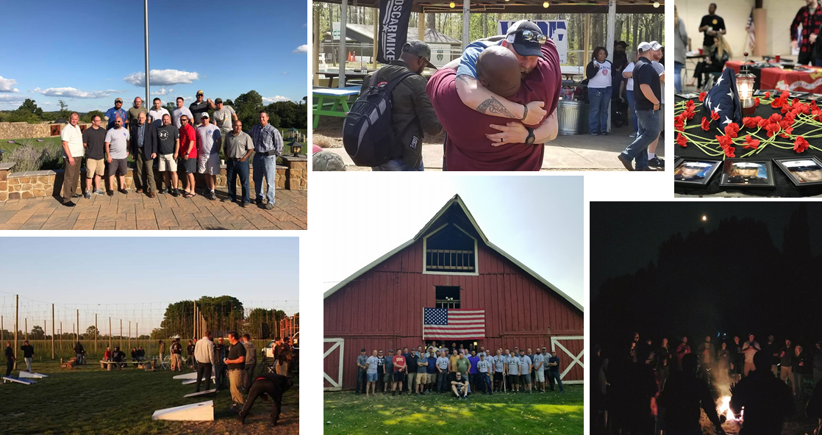

“We’re just over a month removed from the reunion your organization hosted for 2nd Platoon 3/11. As combat veterans, you all know that time is merely a relative measurement that pales in relation to the foremost measurement: Quality Of Life (QOL). You, gentleman, have captured QOL in a bottle. The results of your efforts awaken our souls, restore memories long since lost or buried, and revive the lifeblood of we warriors who can, again, charge into the battle of life with strength in our muscles and hunger in our wills. What other measurement could there ever be? We are renewed. We are reunited with the best version of ourselves. We remember who we were and hold on to that memory as we determine who we will be. We are together. And together we are strong. Hope: the cornerstone. Laughter: the tie that binds. Commitment to the mission; to each other: how boys become Men. You breathe life into us. You must continue your work. We are eternally grateful.”
“When everybody came together it's like we didn't skip a beat. Sitting around a Camp Fire at night reconnecting with everybody. And then General Kelly coming for a visit, which was pretty memorable. Looking back the whole thing was pretty memorable. I know everybody had some tough times after they got out and I think this was exactly something that we all needed.”

FREQUENTLY ASKED QUESTIONS:
Q: What costs should each unit member expect to incur?
A: The only thing we ask of any combat veteran is to get yourself to your reunion – we take care of everything else. For those who need travel support, we take care of that too on an individual, private basis.
Q: What travel support is available to unit members, and how can they access it?
A: WRF will provide travel support to any unit member who communicates a financial need. We take each warrior at their word. Please don’t abuse these limited funds.

Q: What Gold Star family support is provided?
A: We cover all costs associated with attendance for Gold Star family members. GSFs receive 5-Star treatment and personal attention throughout the process. Support is typically focused on nuclear family members (Mom and Dad; brothers/sisters; spouses and children) however, each family situation is unique and is handled on a case-by-case basis.
Q: What about reunion attendance for family members?
A: Based on our experience we strongly believe that the first reunion a unit executes should be focused on unit members, to give each attendee the opportunity to focus fully and completely on reconnection with their fellow warriors (let’s be honest, families often add complication). If a unit is committed to including families our organization will help to establish accommodation options. The cost of attendance for family members is the responsibility of each individual attendee.
Q: How are reunion locations selected?
A: Each unit planning committee is asked to provide a general geographic preference for their reunion. Once this is set, our staff executes a search for all possible venue partners in the desired area, and presents options to the unit planning committee for final selection.
Q: What activities are available during the reunion?
A: The only limit to the activities you can plan is the location of your reunion – if your reunion is in the southeast we will probably not be able to plan a skiing excursion. We have chartered fishing boats, planned skeet shooting competitions, hiked the Appalachian trail, visited the White House…the options are limited only by location and your imagination.
Q: What is your policy on alcohol?
A: We believe every warrior has earned the right to share a drink with their brothers in arms. WRF often partners with local craft breweries and others to provide refreshment options, and we cover the cost of all food and drinks. Because of the insurance liability associated with alcohol, we cannot allow outside beverages to be brought in by unit members. We treat our unit partners as adults and expect them to act that way; attendees who violate that trust will not be able to consume.

